6089-103

CMS APOLLO COMMAND MODULE W/ VU7P AND KU15P

HARDWARE MANUAL

Contents

Introduction 3

To Do: 3

Revision History: 4

Version 1.1.1 4

Front Panel LEDs 5

Front Panel Switches 6

Front Panel Connectors 7

KU15P Fiber Connectors 8

On-Board JTAG Jumpers 9

On-Board LEGACY TTC Jumpers 10

On-Board EEPROM WRITE-PROTECT Jumper 11

On-Board Switches 12

New Board Setup 13

ADDING AN IND045 M3V3 DC-DC CONVERTER 33

DRIVING I2C SLAVES FROM THE AARDVARK HOST ADAPTER 34

OBSERVING I2C MASTERS WITH THE AARDVARK HOST ADAPTER 38

HISTORY LOG 40

S/N 001 40

S/N 002 40

S/N 003 41

GENERAL HISTORY 41

S/N 004 41

S/N 005 41

S/N 006 42

S/N 007 42

S/N 008 43

S/N 009 43

S/N 010 43

# Introduction

This manual can be found in the Windows directory:

\\samba\accuser\cesrdaq\hardware\CMS_Trigger\6089-103_ATCA_mezz\GitHub\CU_PCB_6089-103\Docs

under the file name:

6089-103_Hardware_Manual.docx

This manual will be updated routinely. Old versions will be saved in the same area.

# To Do:

1.

# Revision History:

## Version 1.1.1

1. Initial version

# Front Panel LEDs

There are 7 LEDs on the front panel. Starting at the top of the board near the JTAG connector, the LED functions are:

1) K DONE (GREEN) – The KU15P FPGA has successfully loaded a configuration file, either from the on-board EEPROM or by way of the JTAG chain. This LED is driven by the DONE_0 pin on the KU15P. (SH 5.04)

2) K RGB (RGB) – This is an uncommitted LED that is driven by three signal lines from the KU15P. The firmware design determines the meaning of the display. (SH 2.11)

3) PWR OK (GREEN) – This LED is driven by the BLADE_POWER_OK signal from the TM4C controller. It will be activated when the TM4C has finished turning on all FPGA power supplies and they are all good. Since this is a GPIO pin on the TM4C, the programmer can use flashing to indicate a problem. (SH 2.11)

4) TM4C ACT (GREEN) – This LED is driven by the TM4C_ACTIVE signal. It will be asserted when both the 3.3v and 1.8v management supplies are good, the BLADE_POWER_EN signal from the service blade is high, and the TM4C RESET switch is not activated. (SH 2.11)

5) TM4C RGB (RGB) – This is an uncommitted LED that is driven by three signal lines from the TM4C. The program determines the meaning of the display. (SH 2.11)

6) V DONE (GREEN) – The VU7P FPGA has successfully loaded a configuration file, either from the on-board EEPROM or by way of the JTAG chain. This LED is driven by the DONE_0 pin on the VU7P. (SH 5.04)

7) V RGB (RGB) – This is an uncommitted LED that is driven by three signal lines from the VU7P. The firmware design determines the meaning of the display. (SH 2.11)

# Front Panel Switches

There are 3 switches on the front panel. Starting at the top of the board near the JTAG connector, the switch functions are:

1) K PROG – The KU15P FPGA will try to reload a configuration file from the on-board EEPROM. This switch is not needed when the reload is commanded by the TM4C, nor when the FPGA is being configured by way of the JTAG chain (SH 5.04)

2) TM4C RESET – The TM4C will go through a power-up reset sequence. All switched power supplies will first be disabled before being re-enabled in the proper sequence.

3) V PROG – The VU7P FPGA will try to reload a configuration file from the on-board EEPROM. This switch is not needed when the reload is commanded by the TM4C, nor when the FPGA is being configured by way of the JTAG chain (SH 6.04)

# Front Panel Connectors

There are 9 connectors on the front panel. Starting at the top of the board near the JTAG connector, the connector functions are:

1) JTAG (SH 2.04):

2) TM4C I2C (SH 4.01):

3) K OPTICS I2C (SH 4.01):

4) FPGA I2C (SH 4.01):

5) PWR I2C (SH 4.01):

6) AMC13 CLK IN (SH 2.08):

7) TM4C UART (SH 2.05):

8) CLOCK I2C (SH 4.01):

9) V OPTICS I2C (SH 4.01):

# KU15P Fiber Connectors

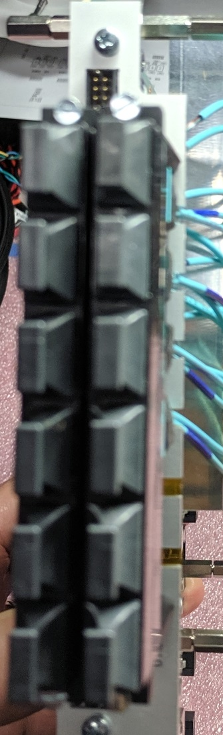

GTY Quad R (133)

FF x4 25 Gbps (U24)

GTY Quad P (131)

FF x4 25 Gbps (U22)

GTY Quad Q (132)

FF x4 25 Gbps (U23)

GTY Quads L/M/N (127/128/129)

FF X12 14 Gbps (U20/U21)

GTH Quads B/C/D (225/226/227)

FF X12 14 Gbps (U104/U105)

GTH Quads H/I/J (231/232/233)

FF X12 14 Gbps (U108/U109)

GTH Quads E/F/G (228/229/230)

FF X12 14 Gbps (U106/U107)

Unused

Unused

# On-Board JTAG Jumpers

There are 4 on-board jumper sites associated with the JTAG chain. They are all located near the front panel, adjacent to the JTAG connector.

1) JTAG NORMAL / BYPASS (SH 2.04): Three pairs of jumpers configure the JTAG chain. The paired jumpers cause the chain to either pass through the associated device (NORMAL) or to jump around the device (BYPASS). Set a pair of jumpers parallel to the front panel to include a device, and perpendicular to bypass a device. Marks on the silkscreen indicate the alignment for NORMAL or BYPASS. The jumpers are labeled V = VU7P, K = KU15P, C = TM4C controller. If a device is not installed, it must be bypassed. The illustration below shows the TM4C as the only device in the chain, with both FPGAs bypassed.

2) JTAG FORCE FRONT PANEL (SH 2.04): The JTAG chain can be driven either from the service module or from the front panel connector. Normally, if no cable is plugged into the front, the chain defaults to being driven by the service module. Plugging in a cable that has pin-13 connected to GND will switch the chain to use signals from the cable. However, if the particular cable does not automatically connect pin-13 to GND, a jumper can be used to force the use of the front panel connector.

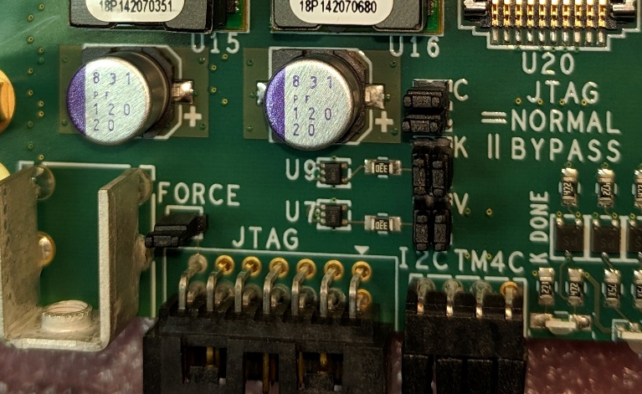

J15 - TM4C Normal

J13 - VU7P Bypassed

J14 - KU15P Bypassed

Front panel JTAG forced

# On-Board LEGACY TTC Jumpers

There are 3 on-board jumper sites associated with the legacy TTC signals. They are all located near the front panel, adjacent to the AMC13 CLK IN SFP connector.

1) CONNECT KU15P or VU7P (SH 2.08): Three pairs of jumpers configure the TTC signals to connect to either the KU15P or the VU7P. Each signal uses 3 pins. The center pin is the signal from or to the legacy TTC electronics. The pin closest to the KU15P connect to the KU15P. The pin closest to the VU7P connects to the VU7P.

Legacy TTC signals can only connect to one FPGA. If both FPGAs need the signals, the FPGA firmware needs to route the signals between the two FPGAs using some of the spare traces (SH 5.07 and 6.07).

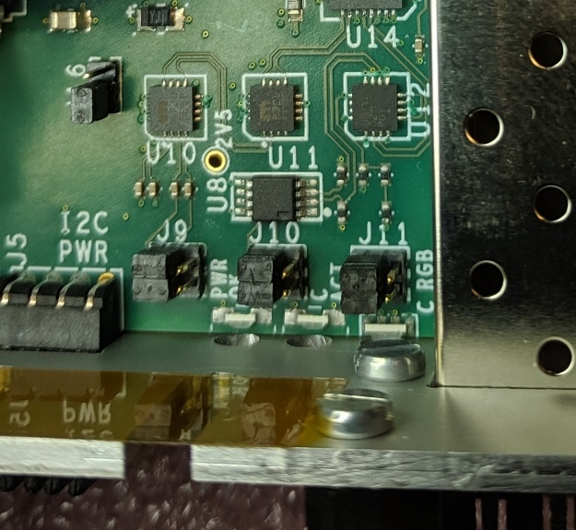

J10 – TTC data to KU15P

J11 – TTS clk/data from KU15P

J9 – TTC clock to KU15P

# On-Board EEPROM WRITE-PROTECT Jumper

There is one on-board jumper that controls the WRITE-PROTECT input of the EEPROM. It is near the front panel, adjacent to the AMC13 CLK IN SFP connector.

1) EEPROM WRITE PROTECT (SH 4.01): This jumper configures the hardware write-protect pin. Pin 1 is closest to the front panel.

a) If no jumper is in place, the hardware write protection is always enabled.

b) If the jumper connects pins 1 and 2, the hardware write protection is always disabled.

c) If the jumper connects pins 2 and 3, the hardware protection is controlled by a GPIO pin on the TM4C controller.

Refer to the data sheet for details about connecting an external high voltage to reset the software write protect fuse.



J16 – EEPROM always writable

# On-Board Switches

There are 2 on-board DIP switches.

1) JTAG (SH 2.04):

# New Board Setup

These steps need to be followed for all new boards.

1) Cut the protruding guideposts on side 2 from the P1 connector.

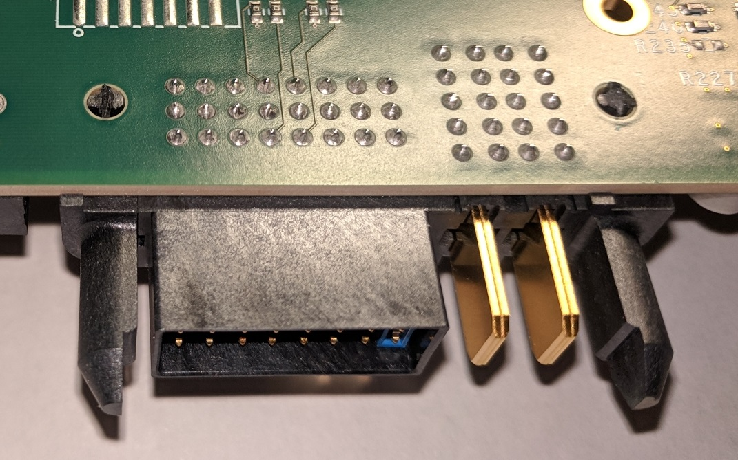

Cut guideposts

2) Install 4 2-mm jumpers on each of the 6 front panel I2C test connectors.

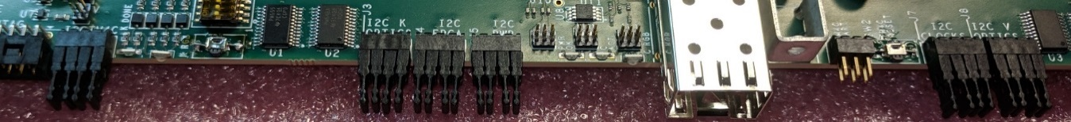

3) Install 3 sets of 2 50-mil jumpers to configure the JTAG chain. The TM4C should be set for NORMAL, and the KU15P and VU7P should be set for BYPASS. The silkscreen legend indicates how NORMAL has the jumpers parallel to the front panel, while BYPASS has them perpendicular to the front panel.

Set of 4 jumpers

Also install a 50-mil jumper on the pins labeled FORCE. This will force the JTAG chain to use only the front panel connector. Eventually, specially wired connectors will be used and the FORCE jumper will be removed. The special connector will connect pin #13 to GND.

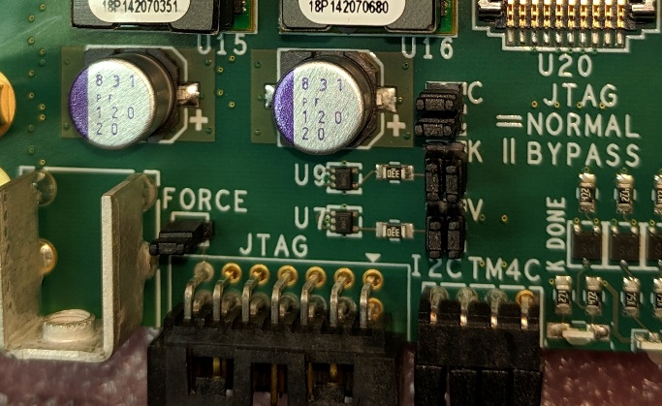

VU7P BYPASS

KU15P BYPASS

TM4C NORMAL

FORCE FRONT PANEL JTAG

Install J9, J10, and J11, the legacy clock routing jumpers, in the position to send the signals to the KU15P. However, if the board does not have a KU15p, or if the board requires using the VU7P for the legacy clock, insert them in the position to send the signals to the VU7P.

Install J16, the EEPROM “write protect” jumper, in the “always writeable” position.



4) Clip pin #6 from the TM4C UART connector on the front edge of the board. This will “key” the header so that the mating connector cannot be inserted in the wrong orientation.

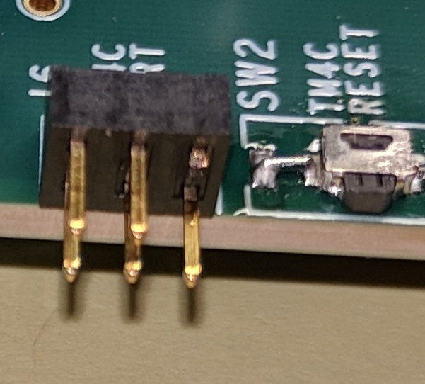

Cut pin #6 (upper right)

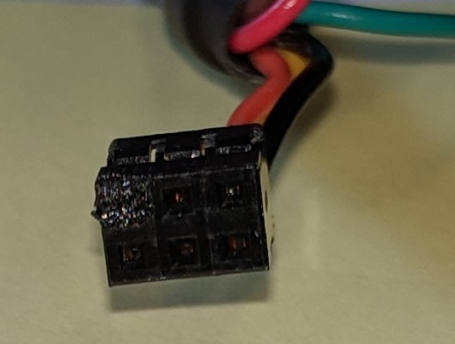

Pin #6 is obstructed

Mount FPGA heatsink backing plates

Apply mylar tape to the back side of two backing plates. The back side is the one opposite the countersunk holes. Do not allow the tape to overlap anywhere. Poke holes in the tape at each of 6 screwholes.

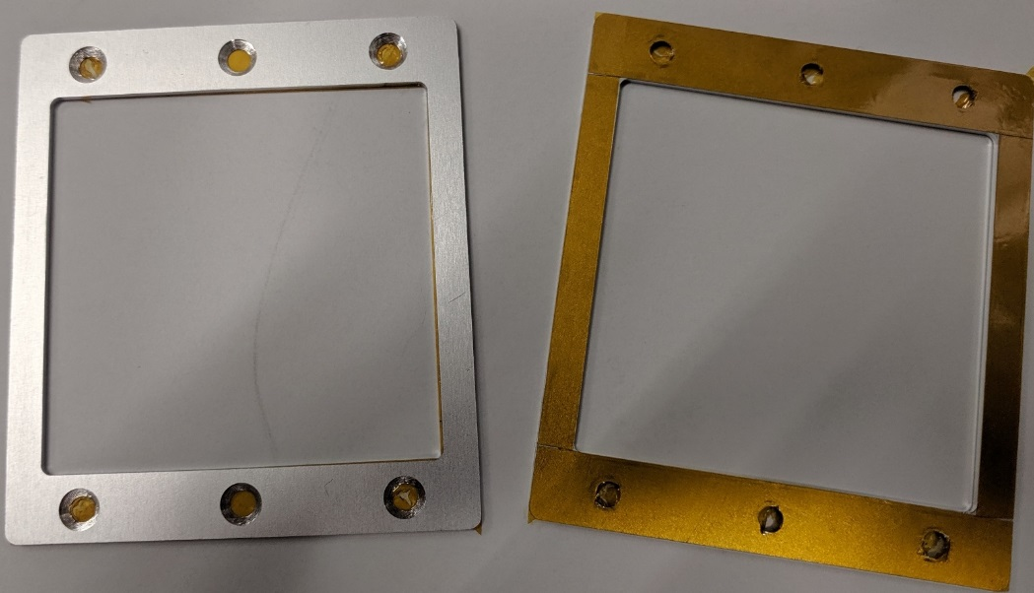

Attach the backing plate to the bottom side of the board, using 4 M3x6 FH screws, 4 M3 lockwashers, and 4 10 mm long M3 threaded standoffs in the corners of the backing plate. The lockwasher and standoff go on the top side of the board. Tighten.

Install 20 mm long M2.5 threaded standoffs in the unused center holes. Insert an M2.5x8 FH or oval head screw from the bottom. On the top side, use an M2.5 flat washer, an M2.5 lockwasher, and the M2.5 standoff. Just make them finger-tight for now. Slip a heatsink over the 6 standoffs. Center and tighten the 20 mm standoffs, making sure the heatsink does not bind on any standoffs.

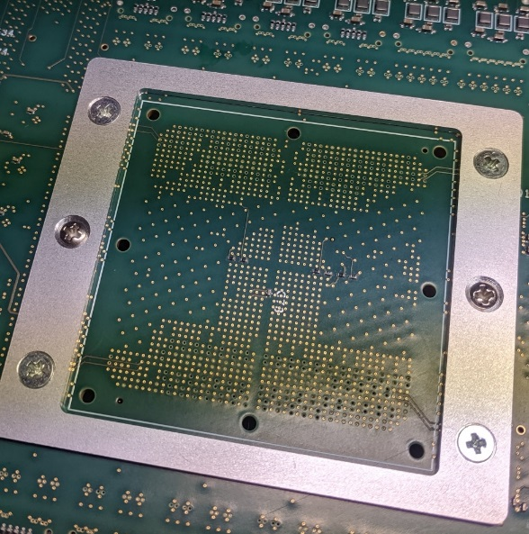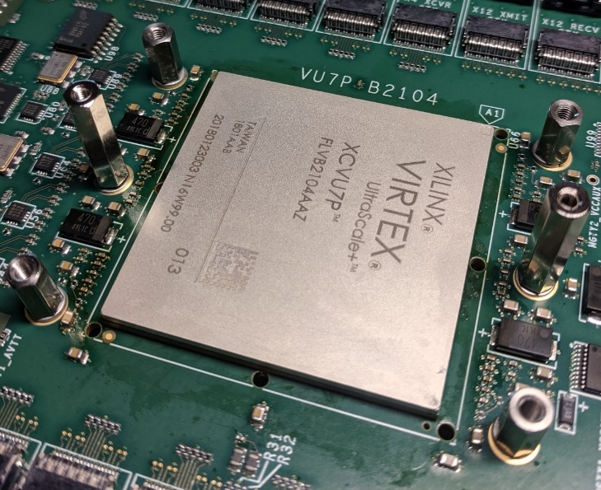

Cut two square pieces of 20 mil thick heatsink foam, one 50 mm x 50 mm for the big chip, and the other 45 mm x 45 mm for the small chip. Peel the cover from one side of the larger piece and place it on the large FPGA. The pieces are slightly larger than the chips and should overlap on all 4 sides. Lightly press it in place and carefully remove the remaining cover. Do not let any bumps or bubbles form in the material.

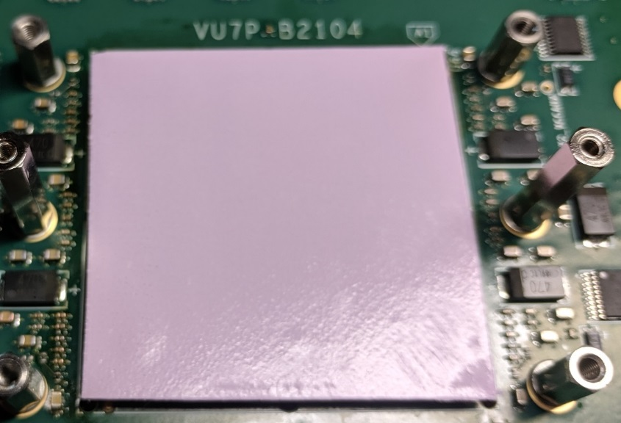

Place a large heatsink over the large FPGA. It gets oriented such that it does not hang over the edge of the board.

Attach the heatsink, using 4 springs, 4 M3x6 round-head screws, 4 M3 flat washers, and 4 M3 lock washers. Drop the springs over the 4 corner standoff, then start the screws about ½ turn. You may need to push the screw down to get the threads to catch. Once all 4 have caught, turn each one a half turn. After all 4 have been turned a half turn, turn each one another half turn. Finish when the top of each screw head is about 2.1 mm to 2.2 mm below the top of the heatsink.

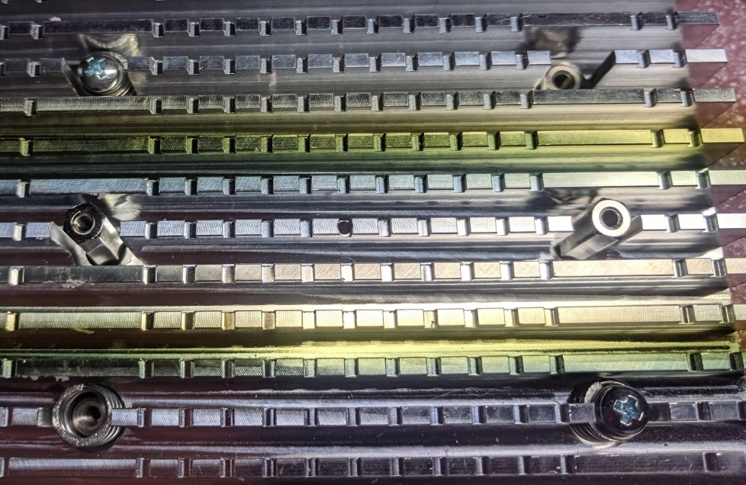

Repeat the process for the small FPGA.

Prepare and attach the front panel

Attach 8 45 mm long M2.5 threaded standoffs to a front panel, using 8 M2.5x6 screws and 8 M2.5 lock washers. The lock washers should be on the face of the panel, under the standoff.

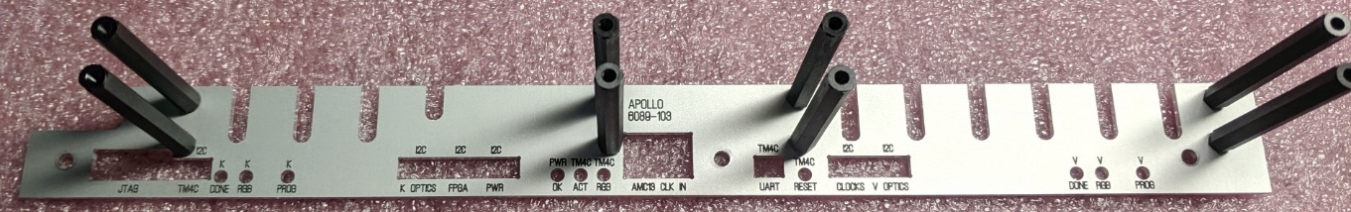

Use 3 M3x6 round head screws to attach the front panel. Slightly squash the springy things on the front of the SFP cage so that the front panel will be removable.

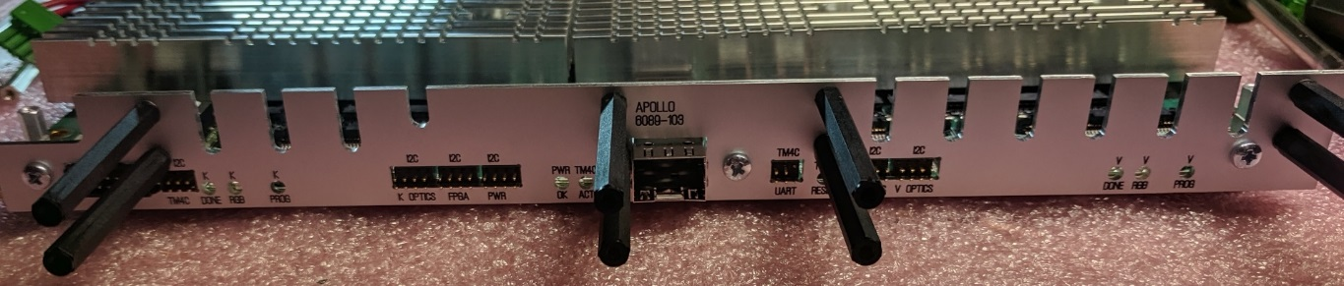

Install 24 2 mm jumpers on the 6 sets of I2C pins that protrude through the front panel. You may need to loosen the front panel mounting screws in order to fir the jumpers fully over the pins.

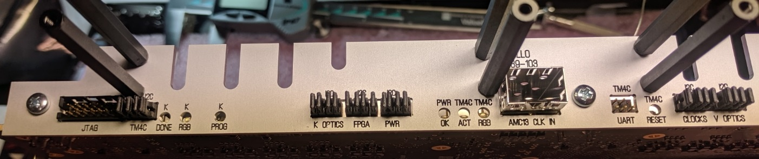

Install FireFly devices and heatsinks

Install 6 8 mm long M2.5 threaded standoffs on the board, using 6 M2.5x6 screws and 6 M2.5 lock washers. The lock washers should be on the bottom side of the board, under the screws. The standoffs go in the holes that are in-line with the FireFly sockets. Two of the six standoffs are shown in the photo.

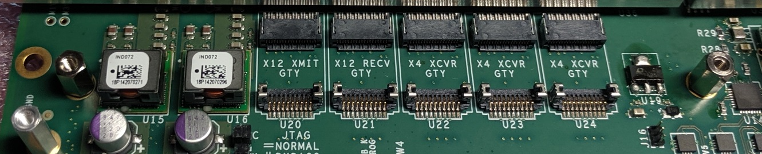

Each FireFly location has 3 labels. One is for the type of FireFly module, one is for the type of Xilinx transceiver block connected to that location, and the third is the connector location reference designator.

X12 XMIT – The transmitter module of a 12-lane pair, marked “T” on the module

X12 RECV – The receiver module or a 12-lane pair, marked “R” on the module

X4 XCVR – A combined 4-lane transmitter and receiver, marked “TR” on the module

GTH – A transceiver with a 14/16 Gbps limit, depending on the chip speed grade

GTY – A transceiver with a 25/28 Gbps limit, depending on the chip speed grade

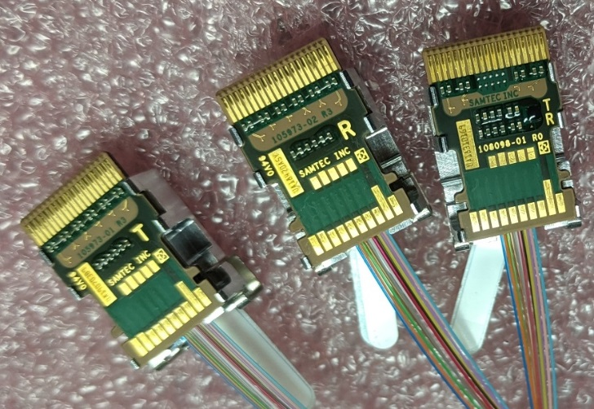

The following table gives all of the details about each FireFly location.

|  |  |  |  |  |  |  |
| --- | --- | --- | --- | --- | --- | --- |
| Reference | FPGA | Quad number | Quad location | Quad type |  |  |
| U20 | KU15P |  | L/M/N | GTY |  |  |
| U21 | KU15P |  | L/M/N | GTY |  |  |
| U22 | KU15P |  | P | GTY |  |  |
| U23 | KU15P |  | Q | GTY |  |  |
| U24 | KU15P |  | R | GTY |  |  |
| U25 | VU7P |  | L | GTY |  |  |
| U26 | VU7P |  | M | GTY |  |  |
| U27 | VU7P |  | N | GTY |  |  |
| U28 | VU7P |  | P | GTY |  |  |
| U29 | VU7P |  | Q/R/S | GTY |  |  |
| U30 | VU7P |  | Q/R/S | GTY |  |  |
| U104 | KU15P |  | B/C/D | GTH |  |  |
| U105 | KU15P |  | B/C/D | GTH |  |  |
| U106 | KU15P |  | E/F/G | GTH |  |  |
| U107 | KU15P |  | E/F/G | GTH |  |  |
| U108 | KU15P |  | H/I/J | GTH |  |  |
| U109 | KU15P |  | H/I/J | GTH |  |  |
| U110 | VU7P |  | B | GTY |  |  |
| U111 | VU7P |  | C | GTY |  |  |
| U112 | VU7P |  | D | GTY |  |  |
| U113 | VU7P |  | E | GTY |  |  |
| U114 | VU7P |  | F | GTY |  |  |
| U115 | VU7P |  | G | GTY |  |  |
| U116 | VU7P |  | H/I/J | GTY |  |  |
| U117 | VU7P |  | H/I/J | GTY |  |  |

Insert the required modules into the connectors. Fan the cables off to the sides. Be sure the two fibers bundles of the transmitter/receiver pairs are not spiraled around each other.

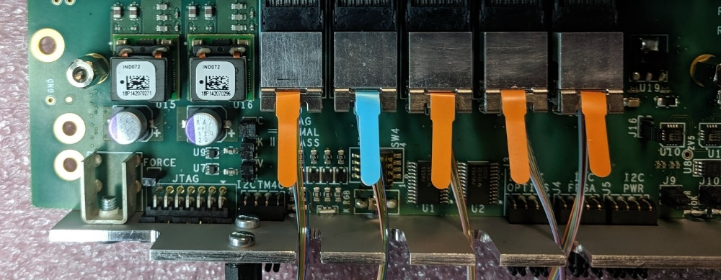

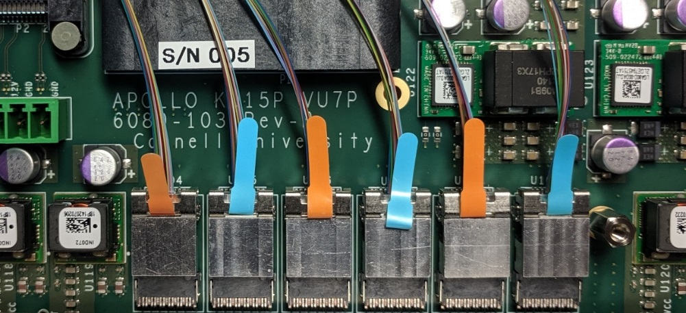

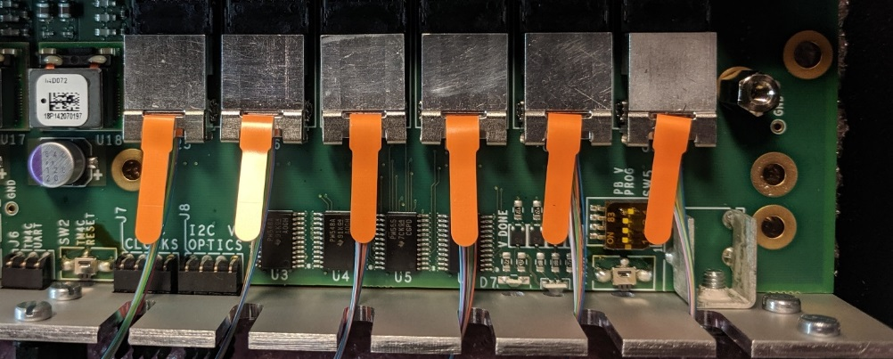

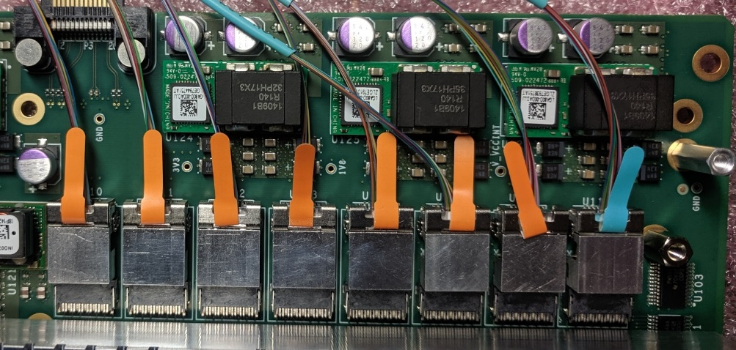

For each bank of FireFly modules, cut one piece of 40 mil thick heatsink foam, and one 20 mil thick piece. The strips are 10 mm (7/16”) wide. The lengths depend on the number of FireFly modules populating a bank.

1 FireFly:

2 FireFlys

3 FireFlys

4 FireFlys

5 FireFlys: 64 mm (2 1/2”)

6 FireFlys: 80 mm (3 1/8”)

7 FireFlys

8 FireFlys: 105 mm (4 1/8”)

Place a 40 mil thick piece of foam over a bank of FireFlys. Be sure that the foam does not overlap the retaining clips, otherwise it will be too thick. Add a second layer of 20 mil foam. If the foam wants to overlap an adjacent regulator or standoff, trim it after removing the backing cover.

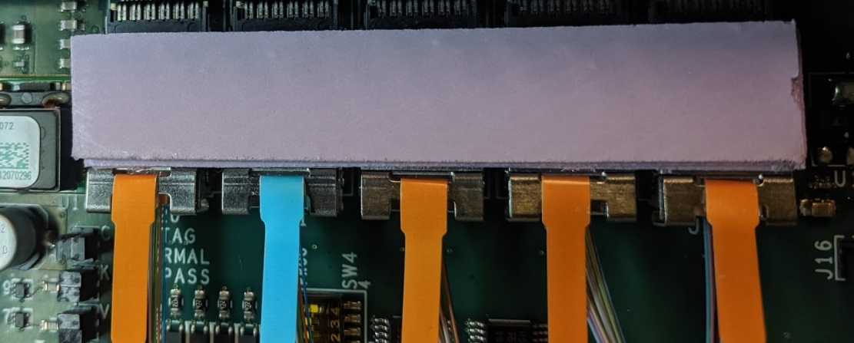

Mount the appropriate front or rear heat sink, using 3 M2.5x12 screws and 3 small springs. Catch each screw about 1 turn in the standoff, then turn them until the tops of the head are level with the top of the heatsink. Finally, turn them until they bottom out against the screw holding the standoff to the board.

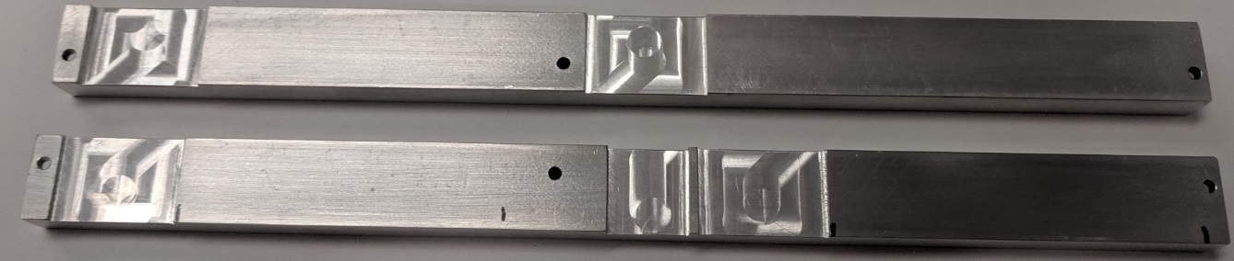

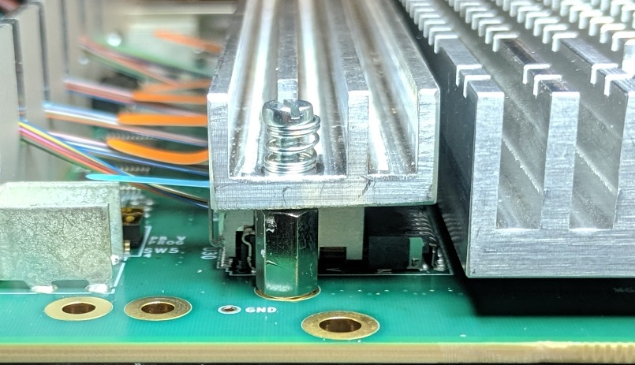

Route the FireFly cables

Make labels for the 4 front panel connector sets.

In the photo, the top left connector block #1 is for the KU15P FireFlys that are mounted to the left as one views the front panel face-on. The labels are on the same side of the connector block as the MTP alignment keys.

In the photo, the top right connector block #2 is for the KU15P FireFlys that are mounted to the right as one views the front panel face-on. The labels are on the opposite side of the connector block as the MTP alignment keys.

In the photo, the bottom left connector block #3 is for the VU7P FireFlys that are mounted to the left as one views the front panel face-on. The labels are on the same side of the connector block as the MTP alignment keys.

In the photo, the bottom right connector block #4 is for the VU7P FireFlys that are mounted to the right as one views the front panel face-on. The labels are on the opposite side of the connector block as the MTP alignment keys.

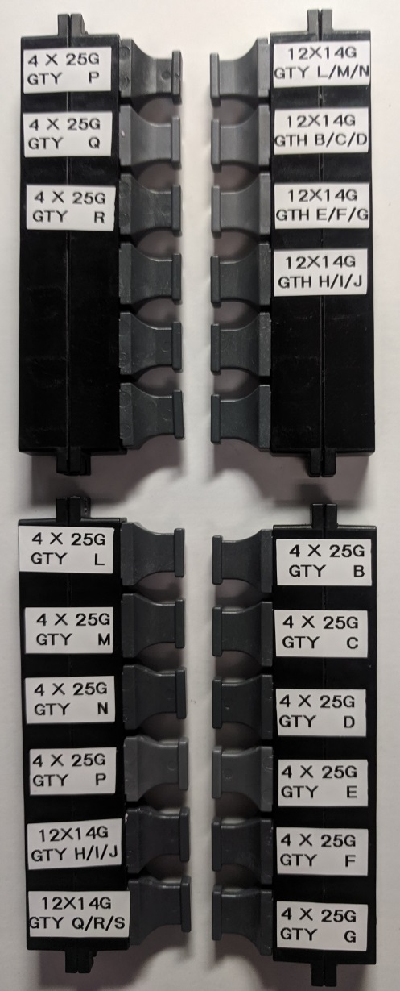

|  |  |  |  |  |  |
| --- | --- | --- | --- | --- | --- |
| Groove (top to bottom) | Source Quad | Direction  L-R or R-L | Has a loop | MTP Header |  |
| 1 | LMN xmit | Left to right | Loop |  |  |
| 2 | LMN recv | Left to right | Loop |  |  |
| 3 | P | Left to right | Loop |  |  |
| 4 | Q | Left to right | Loop |  |  |
| 5 | LMN xmit | Right to left | Loop | Top 1 |  |
| 6 | LMN recv | Right to left | Loop | Top 1 |  |
| 7 | P | Right to left | Loop | Bottom 1 |  |
| 8 | Q | Right to left | Loop | Bottom 2 |  |
| 9 | R | Left to right | Loop |  |  |
| 10 | OPEN |  |  |  |  |
| 11 | BCD xmit | Right to left |  | Top 2 |  |
| 12 | BCD recv | Right to left |  | Top2 |  |
| 13 | R | Right to left | Loop | Bottom 3 |  |
| 14 | EFG xmit | Right to left |  | Top 3 |  |
| 15 | EFG recv | Right to left |  | Top 3 |  |
| 16 | HIJ xmit | Right to left |  | Top 4 |  |
| 17 | HIJ recv | Right to left |  | Top4 |  |

Press the KU15P L/M/N XMIT cable into the #1 groove. Leave it off to the right.

Press the KU15P L/M/N RECV cable into the #2 groove. Leave it off to the right.

Press the KU15P P XCVR cable into the #3 groove. Leave it off to the right.

Press the KU15P Q XCVR cable into the #4 groove. Leave it off to the right.

Position the connector block #1 near the standoffs and plug the KU15P P XCVR cable into the first space.

From left to right, press the KU15P P XCVR cable into the #7 groove. There will be a turn-around loop on the right.

Plug the KU15P Q XCVR cable into the second space.

From left to right, press the KU15P Q XCVR cable into the #8 groove. There will be a turn-around loop on the right.

Press the KU15P R XCVR cable into the #9 groove. Leave it off to the right.

Plug the KU15P R XCVR cable into the third space.

From left to right, press the KU15P R XCVR cable into the #13 groove. There will be a turn-around loop on the right.

Using two M2.5x12 mm screws, attach connector block #1 to the standoffs.

Position the connector block #2 near the standoffs and plug the KU15P L/M/N cable into the first space.

From left to right, press the KU15P L/M/N XMIT cable into the #5 groove. This cable has a dark blue mark near the connector. There will be a turn-around loop on the right.

From left to right, press the KU15P L/M/N RECV cable into the #6 groove. The cable has no marking near the connector. There will be a turn-around loop on the right.

The next photo shows what has been done thus far. All of the front quads have been routed.

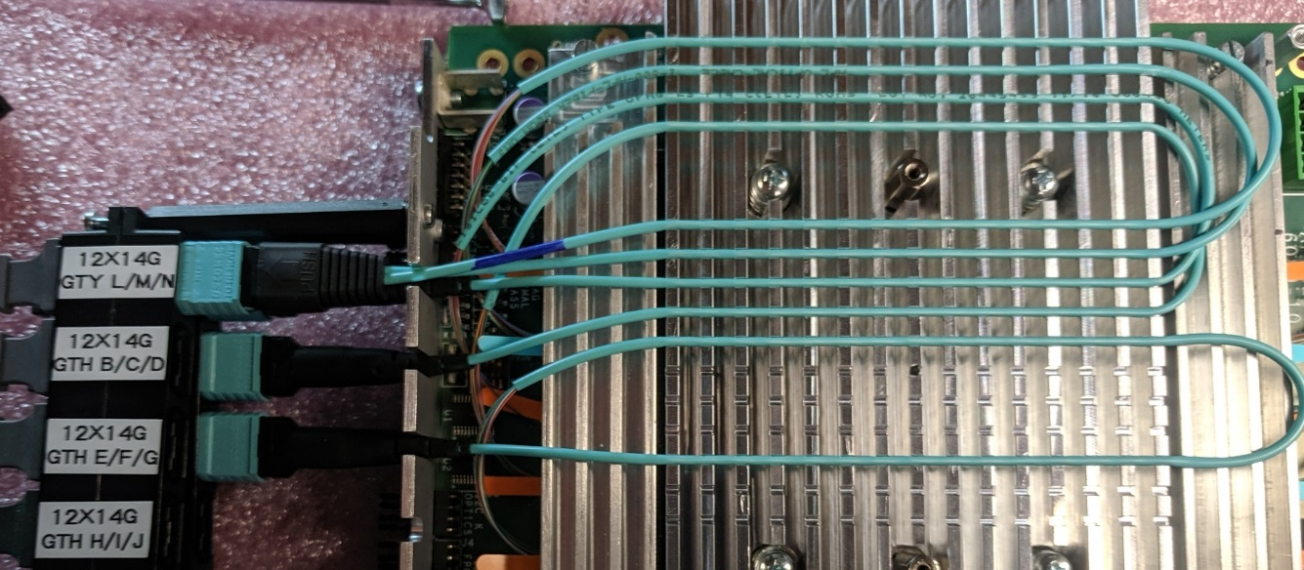

Plug the KU15P B/C/D cable into the second space of connector block #2.

From left to right, press the KU15P BCD XMIT cable into the #11 groove. This cable has a dark blue mark near the connector. There will be slack on the right.

From left to right, press the KU15P L/M/N RECV cable into the #12 groove. The cable has no marking near the connector. There will be slack on the right.

Plug the KU15P E/F/G cable into the third space of connector block #2.

From left to right, press the KU15P EFG XMIT cable into the #14 groove. This cable has a dark blue mark near the connector. There will be slack on the right.

From left to right, press the KU15P EFG RECV cable into the #15 groove. The cable has no marking near the connector. There will be slack on the right.

Plug the KU15P H/I/J cable into the fourth space of connector block #2.

From left to right, press the KU15P H/I/J XMIT cable into the #16 groove. This cable has a dark blue mark near the connector. There will be slack on the right.

From left to right, press the KU15P H/I/J RECV cable into the #17 groove. The cable has no marking near the connector. There will be slack on the right.

Using two M2.5x12 mm screws, attach connector block #2 to the standoffs.

The next photo shows what has been done thus far. All of the KU15P quads have been routed.

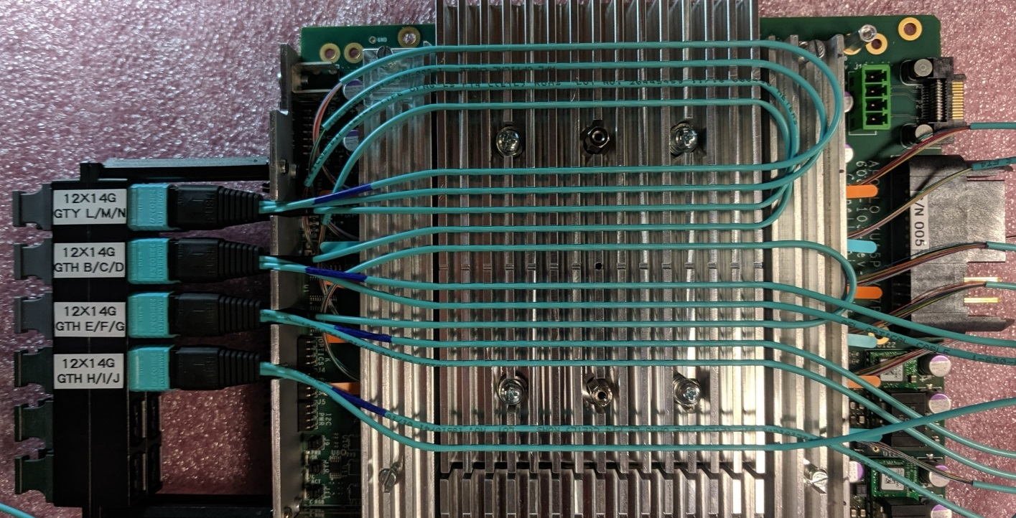

Route the VU7P FireFly cables

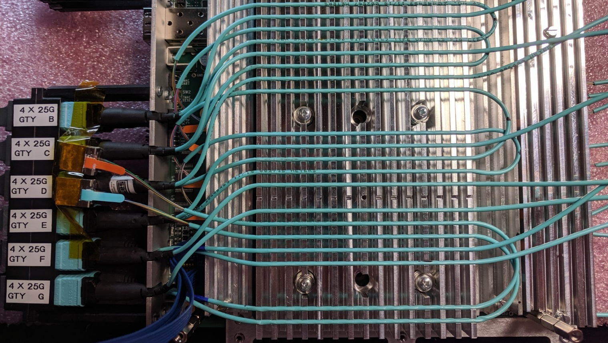

|  |  |  |  |  |  |
| --- | --- | --- | --- | --- | --- |
| Groove (top to bottom) | Source Quad | Direction  L-R or R-L | Has a loop | MTP Header |  |
| 3 | L | Left to right | Loop | Bottom 1 |  |
| 4 | B | Right to left |  | Top 1 |  |
| 5 | M | Left to right | Loop |  |  |
| 6 | L | Right to left | Loop |  |  |
| 7 | C | Right to left |  | Top 2 |  |
| 8 | M | Right to left | Loop | Bottom 2 |  |
| 9 | D | Right to left |  | Top 3 |  |
| 10 | N | Left to right | Loop |  |  |
| 11 | P | Left to right | Loop |  |  |
| 12 | E | Right to left |  | Top 4 |  |
| 13 | N | Right to left | Loop | Bottom 3 |  |
| 14 | P | Right to left | Loop | Bottom 4 |  |
| 15 | F | Right to left |  | Top 5 |  |
| 16 | OPEN |  |  |  |  |
| 17 | G | Right to left |  | Top 6 |  |
| 18 | QRS Xmit | Left to right | Loop |  |  |
| 19 | QRS Recv | Left to right | Loop |  |  |
| 20 | HIJ Xmit | Right to left |  | Bottom 5 |  |
| 21 | HIJ Recv | Right to left |  | Bottom 5 |  |
| 22 | QRS Xmit | Right to left | Loop | Bottom 6 |  |
| 23 | QRS Recv | Right to left | loop | Bottom 6 |  |

Position the connector block #3 near the standoffs.

Press the VU7P L XCVR cable into the #3 groove. Leave it off to the right.

Press the VU7P M XCVR cable into the #5 groove. Leave it off to the right.

Plug the VU7P L XCVR cable into the first space of connector block #3.

From left to right, press the VU7P L XCVR cable into the #6 groove. There will be a turn-around loop on the right.

Plug the VU7P M XCVR cable into the second space of connector block #3.

From left to right, press the VU7P M XCVR cable into the #8 groove. There will be a turn-around loop on the right.

Press the VU7P N XCVR cable into the #10 groove. Leave it off to the right.

Press the VU7P P XCVR cable into the #11 groove. Leave it off to the right.

Plug the VU7P N XCVR cable into the third space of connector block #3.

From left to right, press the VU7P N XCVR cable into the #13 groove. There will be a turn-around loop on the right.

Plug the VU7P P XCVR cable into the fourth space of connector block #3.

From left to right, press the VU7P P XCVR cable into the #14 groove. There will be a turn-around loop on the right.

Plug the VU7P Q/R/S cable into the sixth space of connector block #3.

From left to right, press the VU7P Q/R/S XMIT cable into the #18 groove. This cable has a dark blue mark near the connector. Leave it off to the right.

From left to right, press the VU7P Q/R/S RECV cable into the #19 groove. The cable has no marking near the connector. Leave it off to the right.

From left to right, press the VU7P Q/R/S XMIT cable into the #22 groove. This cable has a dark blue mark near the connector. Leave it off to the right.

From left to right, press the VU7P Q/R/S RECV cable into the #23 groove. The cable has no marking near the connector. Leave it off to the right.

Plug the VU7P H/I/J cable into the fifth space of connector block #3.

From left to right, press the VU7P H/I/J XMIT cable into the #20 groove. This cable has a dark blue mark near the connector. There will be slack on the right.

From left to right, press the VU7P H/I/J RECV cable into the #21 groove. The cable has no marking near the connector. There will be slack on the right.

Using two M2.5x12 mm screws, attach connector block #3 to the standoffs.

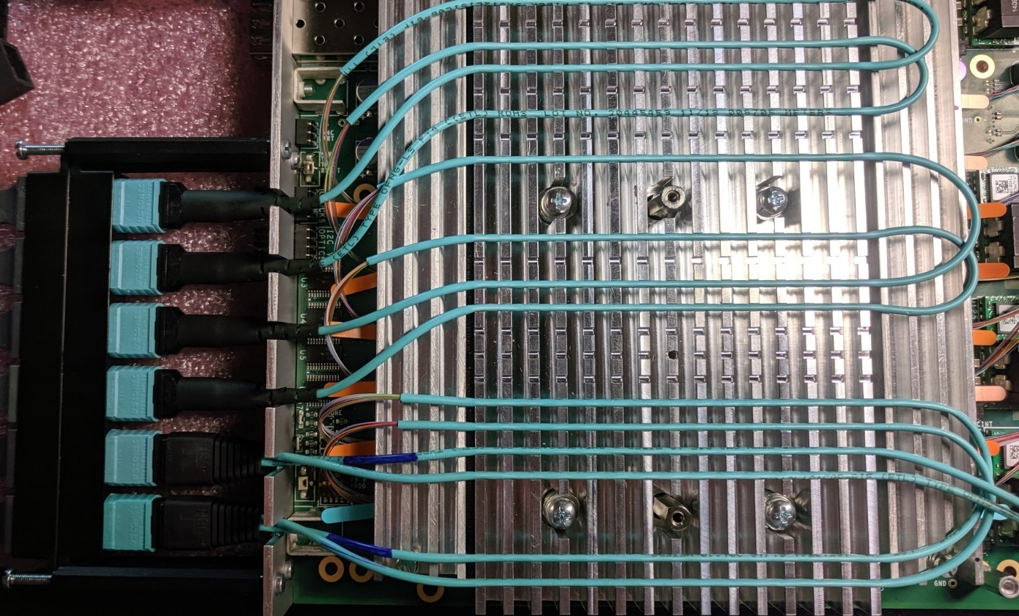

Plug the VU7P B XCVR cable into the first space of connector block #4.

From left to right, press the VU7P B XCVR cable into the #4 groove. There will be a slack on the right.

Plug the VU7P C XCVR cable into the second space of connector block #4.

From left to right, press the VU7P C XCVR cable into the #7 groove. There will be a slack on the right.

Plug the VU7P D XCVR cable into the third space of connector block #4.

From left to right, press the VU7P D XCVR cable into the #9 groove. There will be a slack on the right.

Plug the VU7P E XCVR cable into the fourth space of connector block #4.

From left to right, press the VU7P E XCVR cable into the #12 groove. There will be a slack on the right.

Plug the VU7P F XCVR cable into the fifth space of connector block #4.

From left to right, press the VU7P F XCVR cable into the #15 groove. There will be a slack on the right.

Plug the VU7P G XCVR cable into the sixth space of connector block #4.

From left to right, press the VU7P G XCVR cable into the #17 groove. There will be a slack on the right.

Using two M2.5x12 mm screws, attach connector block #4 to the standoffs.

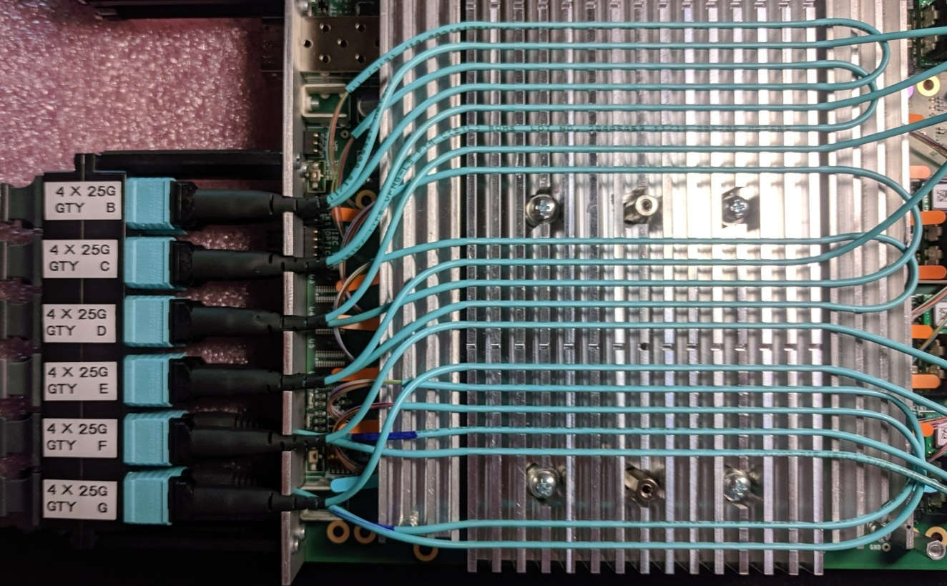

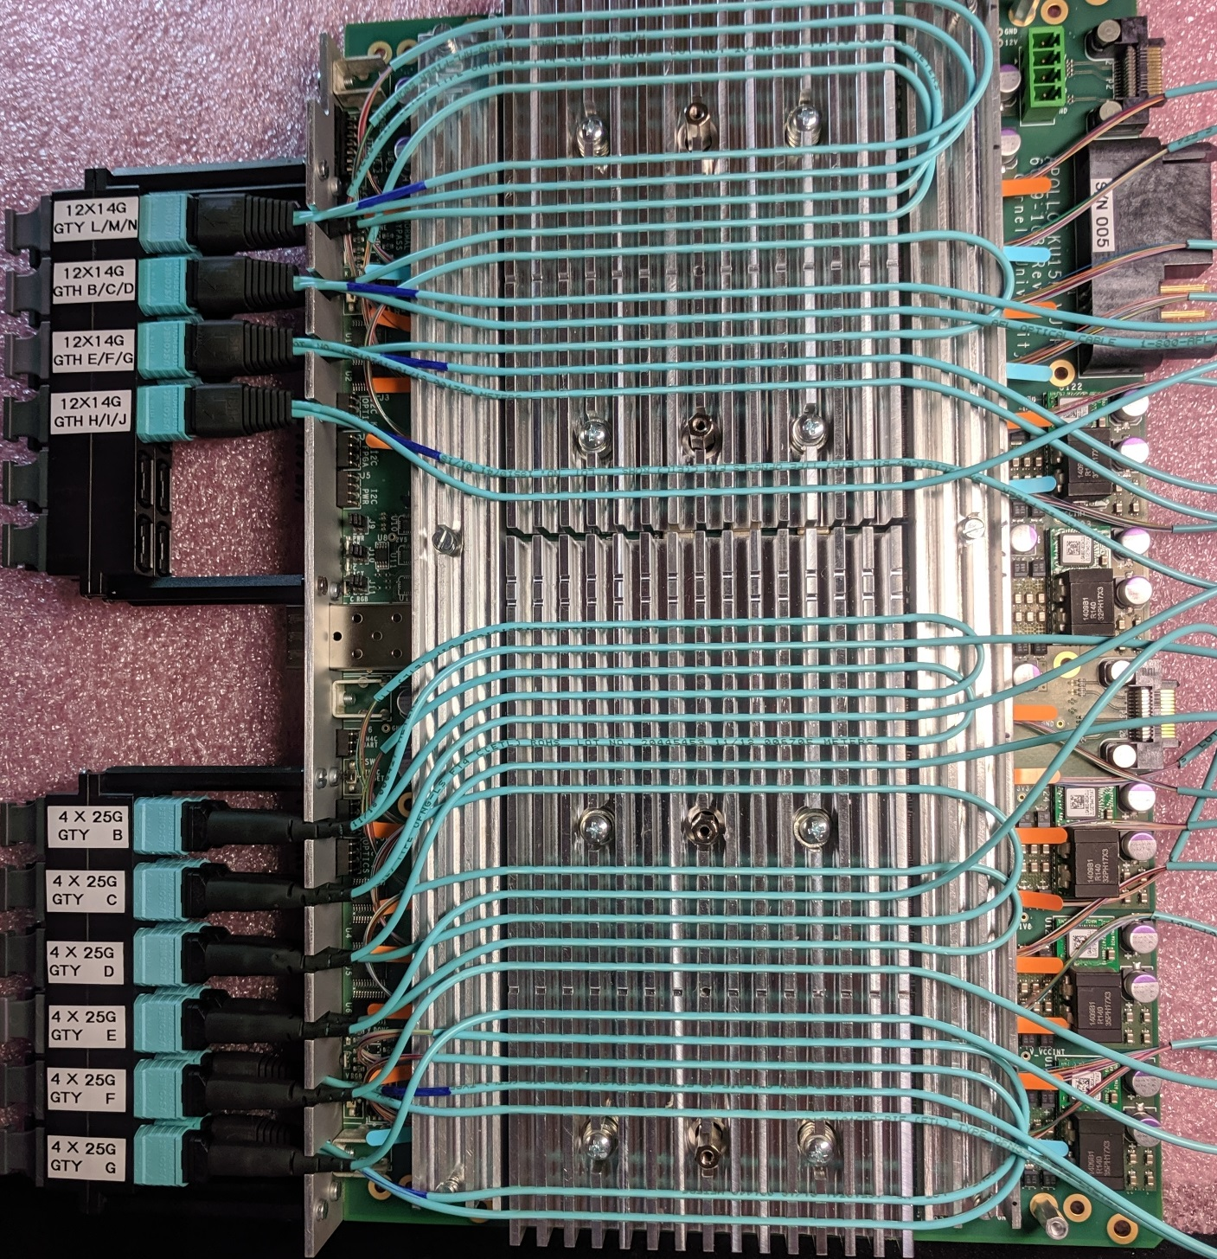

# ADDING AN IND045 M3V3 DC-DC CONVERTER

Four boards had the original M3V3 regulator removed due to mounting difficulties. The new regulator is an IND045. It is mounted “dead bug” style near the big power connector. A piece of “sticky square” holds it to the board.

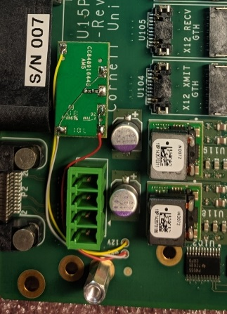 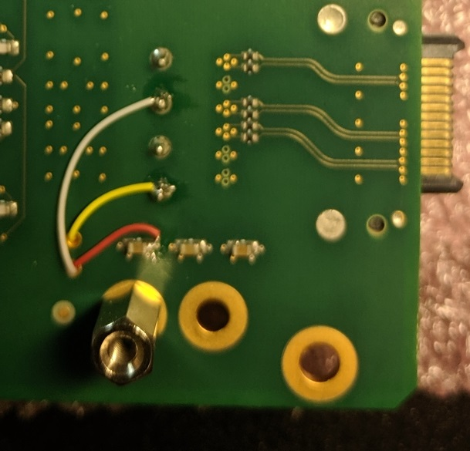

The wire colors are :

Yellow = +12

White = GND

Red = M3V3

The “sense” resistors are a pair of 13.3k resistors in series.

# DRIVING I2C SLAVES FROM THE AARDVARK HOST ADAPTER

Any of the six I2C chains can be driven from an external host adapter. The host adapter is connected by removing the 4 jumpers from the desired I2C chain and attaching the Aardvark I2C/SPI adapter by way of a custom cable, then running the TotalPhase SerialControl program.

The manual is at:

https://www.totalphase.com/support/articles/200468316-Aardvark-I2C-SPI-Host-Adapter-User-Manual

1) Remove the jumpers from the desired I2C slave bus. In this case, it is the I2C bus for the DC-DC converters.

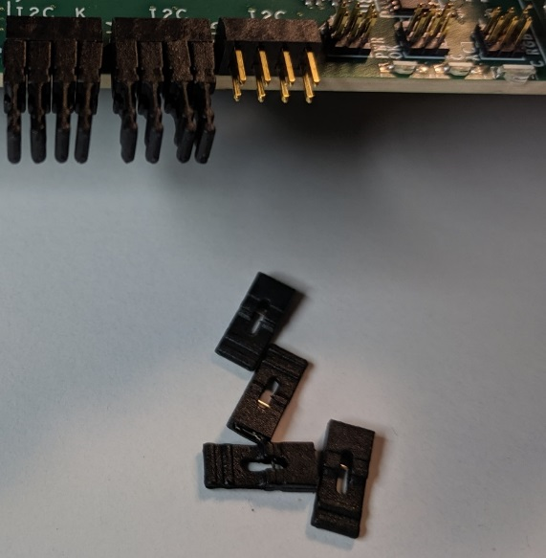

2) Attach the adapter cable that is labeled “BOARD IS SLAVE”. The wires connect to the top row of pins, with the yellow wire to the left and the white wire to the right. The 8-pin front panel connector is not keyed. The 10-pin connector to the adapter is keyed.

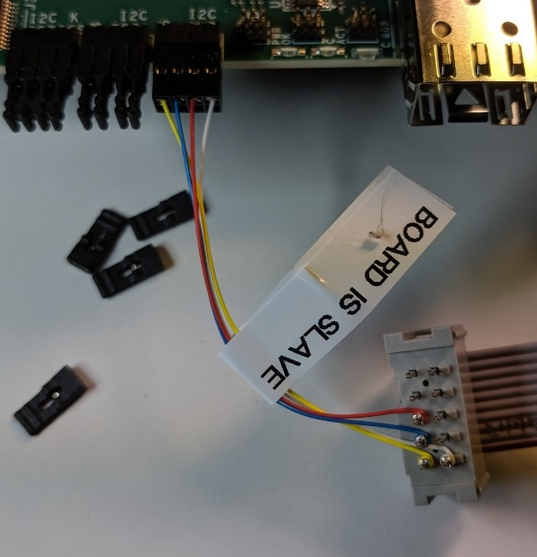

3) The signals are:

Yellow = SCL (I2C Clock)

Blue = SDA (I2C Data)

Red = RESET

White = GND

4) Start the TotalPhase “Control Center Serial” program. From the menu bar, select “Adapter” Then scroll down to “I2C + GPIO”.

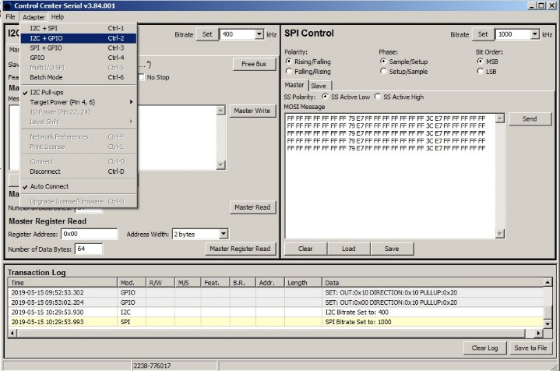

5) The right side of the screen will change from “SPI Control” to “GPIO Control”. GPIO #2 drives the active-low “reset” signal. It needs to be high for normal operation. Select the direction for GPIO #2 to be “Out”, set the “Out Set” value to be “1’”, and press the “Set” button.

Anytime you want to perform a reset operation, set the “Out Set” value to “0” and press the “Set” button. Then set the “Out Set” value to be “1’”, and press the “Set” button again.

GPIO #2 to “Out”

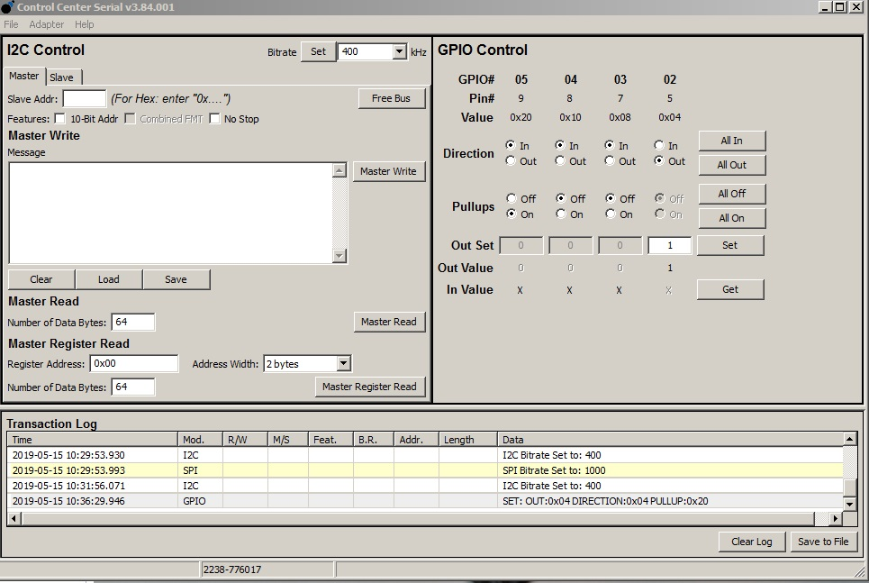

Press to activate

“Out” to 1

6) To configure a TCA9548A bus switch, set the “Bitrate” to “100 kHz”, set the “Slave Addr” to 0x70, and the “Master Write” message to the hex data representing the switch bits to set. Press the “Master Write” button. Read it back by setting the “Master Read” number of data bytes to 1 and pressing the “Master Read” button. The results show in the “Transaction Log” window.

Bitrate to 100 kHz

Write message to 1

Slave Addr to 0x70

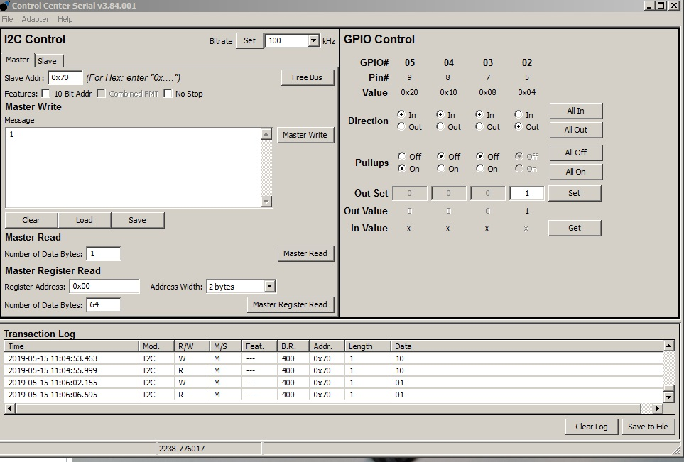

Result of read

Read bytes to 1

# OBSERVING I2C MASTERS WITH THE AARDVARK HOST ADAPTER

Any of the six I2C chains can be substituted with the external host adapter. The host adapter is connected by removing the 4 jumpers from the desired I2C chain and attaching the Aardvark I2C/SPI adapter by way of a custom cable, then running the TotalPhase SerialControl program.

1) Remove the jumpers from the desired I2C slave bus. In this case, it is the I2C bus for the DC-DC converters.



2) Attach the adapter cable that is labeled “BOARD IS MASTER”. The wires connect to the bottom row of pins, with the yellow wire to the left and the white wire to the right. The 8-pin front panel connector is not keyed. The 10-pin connector to the adapter is keyed.

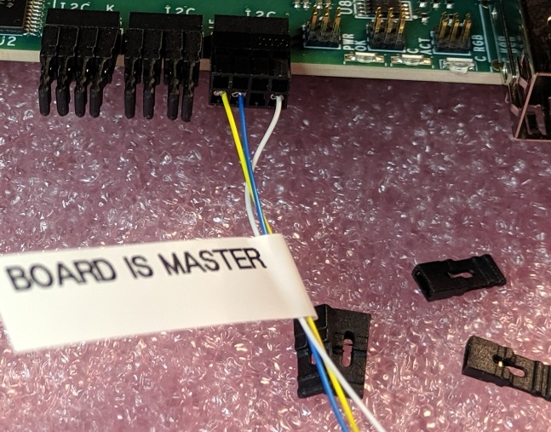

3) The signals are:

Yellow = SCL (I2C Clock)

Blue = SDA (I2C Data)

Red = RESET (omitted initially until all TM4C I2C reset pins are open drain)

White = GND

# HISTORY LOG

This section of the manual contains a log of the history for each board, according to the serial number.

## S/N 001

This is one of the three first build prototypes.

1. The initial modifications described in the “problems” section of the 6089-103_checkout.docx document were performed.

Mod 3: Installed proper size capacitors

Mod 4:Resistors removed

Mod 5: GND jumpers added

Mod 6: Load resistors will not be added to prototype boards, except S/N 002

Mod 7: Resistors either removed or changed

Mod 11: LED resistors not yet changed

Mod 12: LGA80D resistors not yet changed

2. The KU15P MGTH_AVCC regulator, U118, did not work. It would click and put out voltage pulses. It was sent back to MPL to be replaced and now it is fine, but the adjacent U119 regulator is now clicking and does not normally work. However, if I put pressure with my finger, it can be made to work. It sounds like the rework disturbed the adjacent part. MPL has been contacted for analysis.

We could ignore the KU15P power problems and have a VU7P soldered to this board?

## S/N 002

This is one of the three first build prototypes.

1. The initial modifications described in the “problems” section of the 6089-103_checkout.docx document were performed.

Mod 3: Installed proper size capacitors

Mod 4:Resistors removed

Mod 5: GND jumpers added

Mod 6: Load resistors were added to only this board

Mod 7: Resistors either removed or changed

Mod 11: LED resistors were changed

Mod 12: LGA80D resistors were changed

2. The socket for the KU15P was installed, and a KU15P was inserted.

3.The socket for the VU7P was installed. However, no FPGA was inserted, so this board has an empty socket.

4. The full complement of KU15P FireFly devices was installed.

5. The board was sent to BU. They have not reported any problems with the stuff that they have tested. The have used the chip-2-chip links from the Zynq. I don’t believe they have done anything with FireFlys.

## S/N 003

This is one of the three first build prototypes.

1. The initial modifications described in the “problems” section of the 6089-103_checkout.docx document were performed.

Mod 3: Installed proper size capacitors

Mod 4:Resistors removed

Mod 5: GND jumpers added

Mod 6: Load resistors will not be added to prototype boards, except S/N 002

Mod 7: Resistors either removed or changed

Mod 11: LED resistors not yet changed

Mod 12: LGA80D resistors were changed

## GENERAL HISTORY

Seven more boards were assembled (S/N 004 through S/N 010). The BOM had been modified so that that only remaining modification from the initial mods was Mod 5 (adding GND jumpers).

A problem was discovered with the M3V3 regulator U31. It was not properly soldered on 4 of the 7 boards. Rather than fix it, a decision was made to replace it with an IND045. The four boards were sent to MPL to have U31 and the voltage setting resistors removed. The IND045 was added at Cornell.

## S/N 004

This is one of the seven second build prototypes.

1. The remaining initial modification described in the “problems” section of the 6089-103_checkout.docx document was performed.

Mod 5: GND jumpers added

2. The socket for the KU15P was installed, and a KU15P was inserted.

3. The socket for the VU7P was installed, and a VU7P was inserted.

4. This board was mated to the SM and set up for testing at the PSB. It does not have any FireFly modules.

## S/N 005

This is one of the seven second build prototypes.

1. The remaining initial modification described in the “problems” section of the 6089-103_checkout.docx document was performed.

Mod 5: GND jumpers added

2. The board was sent to MPL to have both a KU15P and a VU7P soldered.

3. All FireFly modules for both FPGAs were installed.

4. This board was set up in the PSB with fiber optic cables and loopbacks so that Ed from Rutgers could test them.

5. Ed’s initial report was that a set of links did not work after first loading the bit file, but worked fine after reloading the bit file. This sounds like some type of initialization problem, and not a board/hardware problem.

## S/N 006

This is one of the seven second build prototypes.

1. The remaining initial modification described in the “problems” section of the 6089-103_checkout.docx document was performed.

Mod 5: GND jumpers added

2. When power was applied, the board exhibited a dead short from +12 to GND, drawing significant current. This was assumed to be related to the U31 mounting problem, so the board was sent to MPL to have U31 and its resistors removed.

3. The IND045 for M3V3 was added and tests OK

4. The MCU was programmed with “project2_27Aug19.bin”. Upon power-up, the KU15P supplies were all OK. The VU7P supply U121 (MGTY2_AVTT) does not put out any voltage. An NG tag was put on it.

This may be good for a KU15P.

## S/N 007

This is one of the seven second build prototypes.

1. The remaining initial modification described in the “problems” section of the 6089-103_checkout.docx document was performed.

Mod 5: GND jumpers added

2. When power was applied, the board did not generate any voltage on M3V3. This was assumed to be related to the U31 mounting problem, so the board was sent to MPL to have U31 and its resistors removed.

3. The IND045 for M3V3 was added and tests OK.

4. The MCU was programmed with “project2_27Aug19.bin”. Upon power-up, the KU15P supplies were all OK and the VU7P power supplies were all OK.

This board is ready for both FPGAs

## S/N 008

This is one of the seven second build prototypes.

1. The remaining initial modification described in the “problems” section of the 6089-103_checkout.docx document was performed.

Mod 5: GND jumpers added

2. When power was applied, the voltage on M3V3 tracked the input voltage on +12v I think it only went up to about 4.5 volts, but there may be non-apparent chip damage. This was assumed to be related to the U31 mounting problem, so the board was sent to MPL to have U31 and its resistors removed.

3. The IND045 for M3V3 was added and tests OK.

4. The MCU was programmed with “project2_27Aug19.bin”. Upon power-up, the KU15P supplies were all OK and the VU7P power supplies were all OK.

This board is ready for both FPGAs

## S/N 009

This is one of the seven second build prototypes.

1. The remaining initial modification described in the “problems” section of the 6089-103_checkout.docx document was performed.

Mod 5: GND jumpers added

2. When power was applied, the voltage on M3V3 was fine, so the U31 regulator was left unchanged.

3. The MCU was programmed with “project2_27Aug19.bin”. Upon power-up, the KU15P supplies were all OK and the VU7P power supplies were all OK.

This board is ready for both FPGAs

## S/N 010

This is one of the seven second build prototypes.

1. The remaining initial modification described in the “problems” section of the 6089-103_checkout.docx document was performed.

Mod 5: GND jumpers added

2. When power was applied, the board did not generate any voltage on M3V3. This was assumed to be related to the U31 mounting problem, so the board was sent to MPL to have U31 and its resistors removed.

3. The IND045 for M3V3 was added and tests OK

4. The MCU was programmed with “project2_27Aug19.bin”. Upon power-up, the KU15P supplies were all OK and the VU7P power supplies were all OK.

This board is ready for both FPGAs